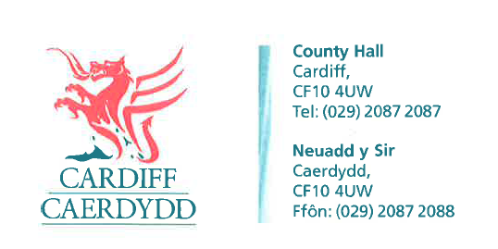
FOI Response Document
FOI17117

Thank you for your request under the Freedom of Information Act 2000 about Road Improvements received on 10/12/2021.
Request
How much money has Cardiff Council spent on road improvements each financial year from 2017/2018 to date?
We have considered your request and enclose the following information:
Response
Cardiff Council can advise the following:

 | 17/18 | 18/19 | 19/20 | 20/21 | 21/22
 | actual | actual | actual | actual | budget
 | £000's | £000's | £000's | £000's | £000's
Revenue | 2,076 | 1,480 | 2,160 | 1,596 | 2,171
Capital | 2,809 | 4,639 | 3,800 | 5,721 | 7,251
total | 4,885 | 6,119 | 5,960 | 7,317 | 9,422

If you have any queries or concerns, please do not hesitate to contact us.
Please remember to quote the reference number above in any future communications.

